ASSIGNMENT

* **MODUL-1(HTML)**

**• ARE the HTML tags and elements the same thing?**

NO, Tags and elements both are different in html.

* **HTML TAGS** –Tags which used to hold the html elements. Tags starts with < and end with> brackets.
* **HTML ELEMENTS**-When tag insert content so it’s become html elements.
* **EXAMPLE**

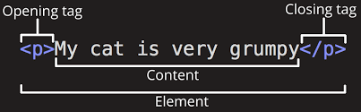

**• What are tags and attributes in HTML?**

* **Tags:**-Tags used for hold the element of HTML. All tags write in angle brackets (<>).

**For example :-** <title></title>

* **Attributes: -** Tags have additional properties in piece of information is called Attributes of tags.in tags attributes place piece of information.

**For example :-**<a href=”http/google.com”> in this anchor tag href is the attribute of anchor tag.

**• What are void elements in HTML?**

A void elements is an element whose content model never allows it to have contents under any circumstances.in simple a void element don’t have any contents so it’s also called an empty tag.in html img,br,hr,link,meta etc. All are void or empty elements.

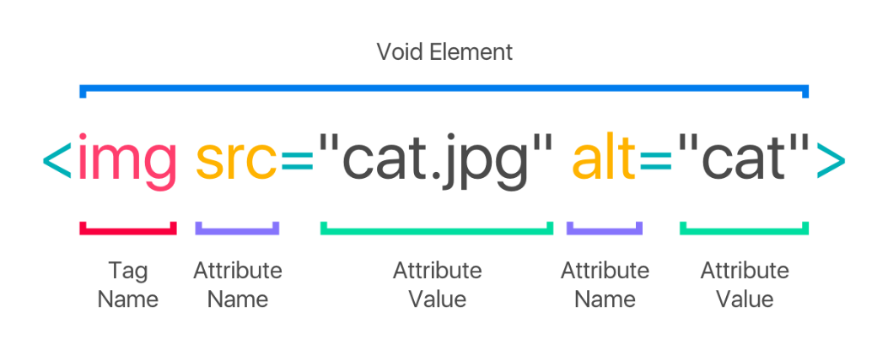

**• What are HTML Entities?**

An html entity is a piece of text that begins with an ampersand (&) and ends with a semicolon (;) entities used for display reserved characters and invisible characters.

**For example:-** 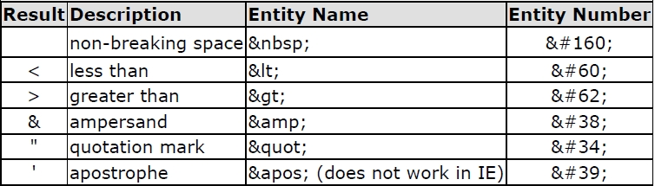

**• What are different types of lists in HTML?**

Html lists allowed web developers to group a set of related items in lists .There are three types of lists in html.

* ***ordered list***
* ***Unordered list***
* ***definition or description list***
* **Order list**

An order list starts with the <ol>tag. Each list item starts with the <li>tag.

**Example**

<ol>

<li>Gujarati</li>

<li>Punjabi</li>

<li>Rajasthani</li>

</ol>

* **Unorder list**

An unordered list starts with the <ul>tag. Each list items starts with the <li>tag.

Example

<ul>

<li>coffee</li>

<li>tea</li>

<li>milk</li>

</ul>

* **Definition or description list**

A description list is a list of terms, with a description of each term. The <dl> tag defines description list, the <dt> defines the description title or name, the <dd> defines the description data.

**Example**

<dl>

<dt>coffee></dt>

<dd>black hot drink</dd>

<dt>milk</dt>

<dd>white cold drink</dd>

</dl>

* And ***Nested list*** also a one type of list in html.this list is list inside the another list.

**Example**

<ol>

<li>Gujarati</li>

<ol>

<li>salad</li>

<li>roti</li></ol>

<li>Punjabi</li></ol>

**• What is the ‘class’ attribute in HTML?**

The class attribute specifies one or more class names for an elements. The class attribute is mostly used to point to a class in style sheet. The class attribute is part of the global attributes and can be used on any html elements.

**Example**

<Html>

<head>  
<style>  
h1.intro {  
    color: blue;  
}  
  
p.important {  
    color: green;  
}  
</style>  
</head>  
<body>  
  
<h1 class="intro">Header 1</h1>  
<p>A paragraph.</p>  
<p class="important">Note that this is an important paragraph. :)</p>  
  
</body>  
</html>

**• What is the difference between the ‘id’ attribute and the ‘class’ attribute of HTML elements?**

The only difference id attribute and class attributes that id is unique in a page and can apply to at most one element while class attribute can apply to multiple elements.

**Example of id and class attributes:-**

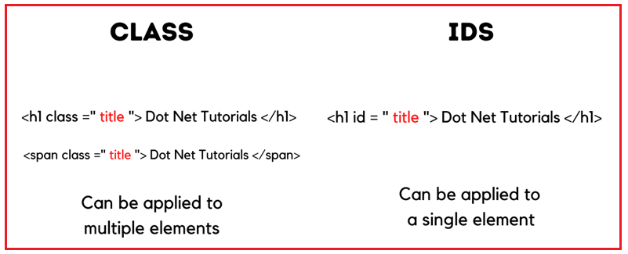

**• What are the various formatting tags in HTML?**

The html formatting elements were designed to display special types of text. And html formatting process that allows us to format text to increase its visual appeal.

**For html formatting tags**

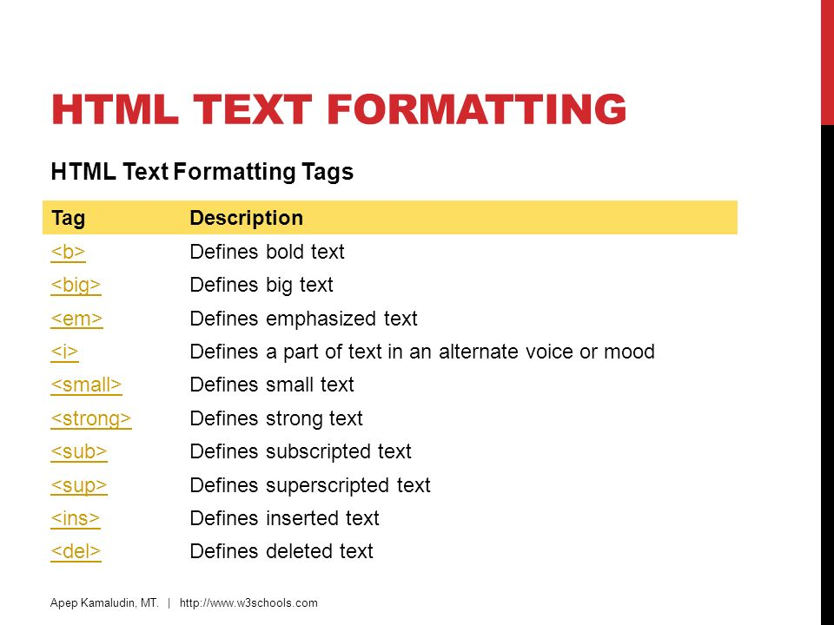

**• How is Cell Padding different from Cell Spacing?**

* **Cell padding**

The cell padding attribute places spacing around data within each cell.

* **Cell spacing**

The cell spacing attribute places space around each cell in the table.

**Example**

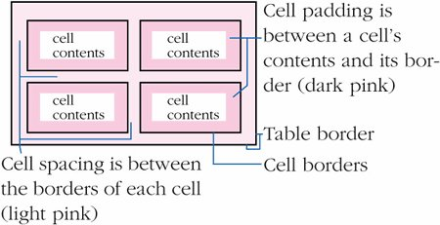

**• How can we club two or more rows or columns into a single row or column in an HTML table?**

It can be done by using the rowspan and colspan attribute in html. The rowspan is used to merge or combine the numbers of cells in a row where’s the colspan is used to merge column cells in a table.

**Example:-**

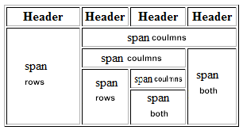

**• What is the difference between a block-level element and an inline element?**

* **Block level element**

Block level element always starts on a new line, and always takes up the full width available.

* **Inline element**

Inline elements occupy only much width as necessary. And does not start on a new line.

**Example:-**

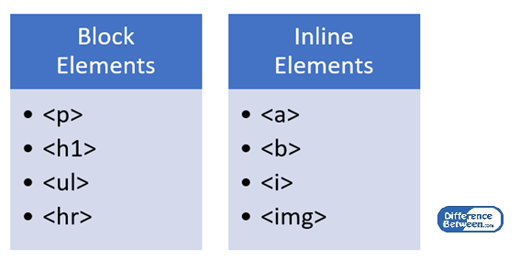

**• How to create a Hyperlink in HTML?**

In html, we specify a link using the<a>tag.

**Explanation:** <a></a>this is the anchor tag that create a hyperlink. Anything between this tags becomes part of the link.

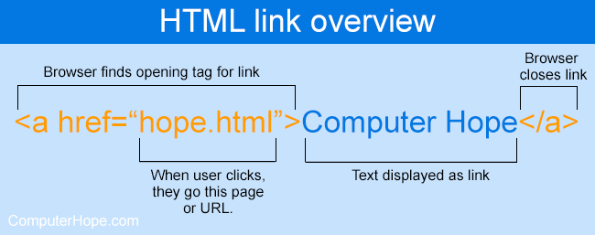

**• What is the use of an iframe tag?**

The iframe in html stands for inline frame. The iframe tag defines a rectangular region within the

document in which the browser can display.

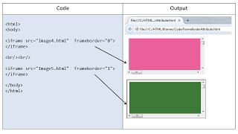

**• What is the use of a span tag? Explain with example?**

The <span>tag is an inline container used to mark up a part of a text, or a part of a document. The <span>tag is much like the <div>element, but<div>is a block level element and <span>is an inline level.

**Example**:-

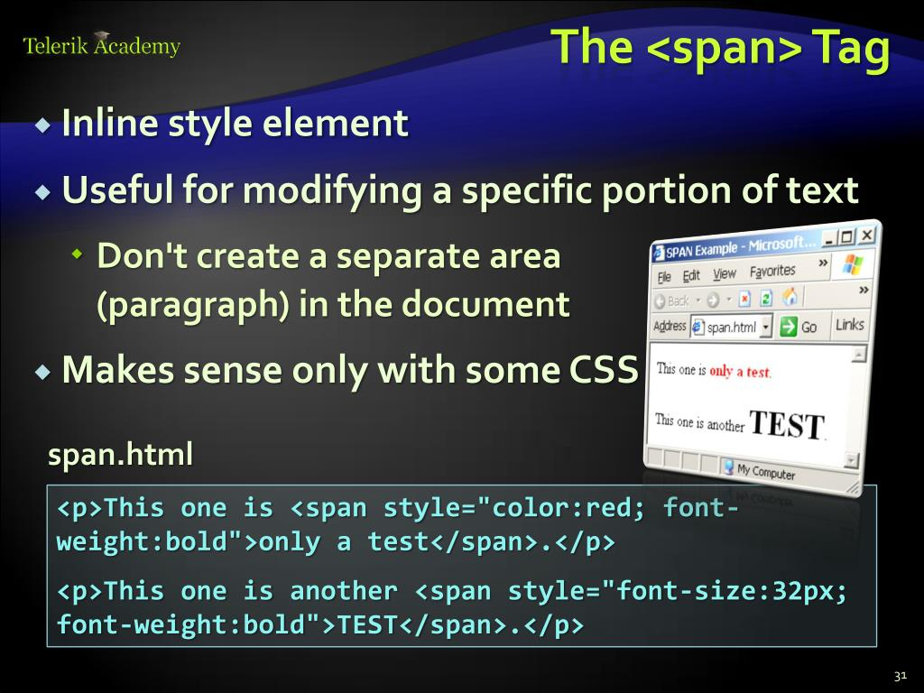

**• How to insert a picture into a background image of a web page?**

To set the back ground image of a web page, use the <style>tag, add the property background image. The property sets a graphic such as jpg, png, svg, gif, etc.

**Example**

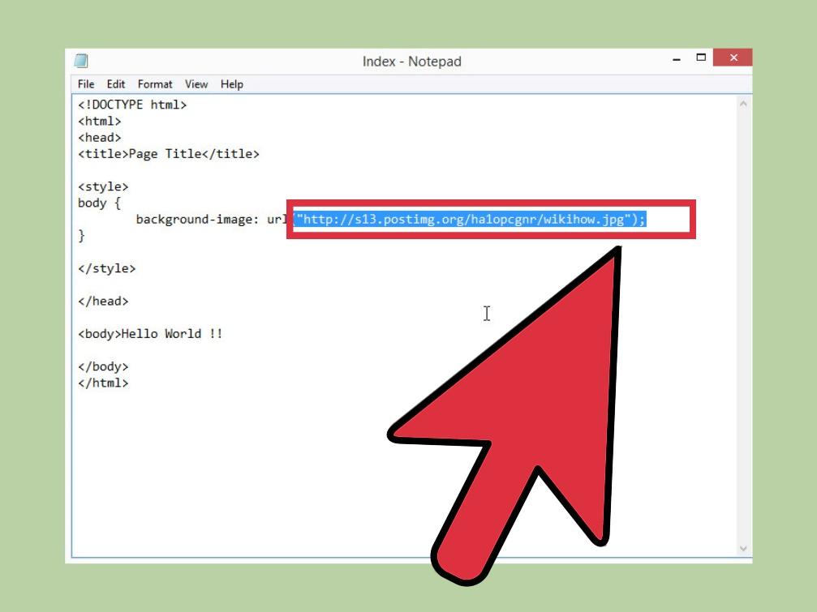

**• How are active links different from normal links?**

* Normal links are links which are there on the page and have not been clicked yet.
* Active links are those links, which have just been clicked at that instant.

Websites are designed to point you to different resources. You can move from one website to another through links. Links help you to get information from different resources. Links are established in simple HTML web pages through [<a>](https://www.geeksforgeeks.org/html-a-tag/)tag.  
Links are categorized into three types. Typically a Link is displayed in three different colors based on the usage.

* Normal links (Unvisited links)
* Visited links
* Active links

**EXAMPLE:-**

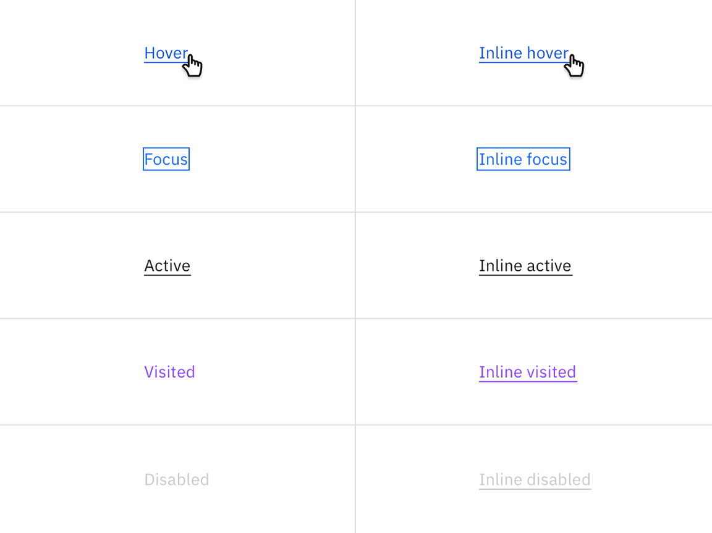

**• What are the different tags to separate sections of text?**

* <br> tag-it is used to separate the line of text. It breaks the current line and shifts the flow of the text to a new line.
* <p> tag-this tag is used to write a paragraph of text.
* <blockquote> tag-this tag is used to define large quoted sections.

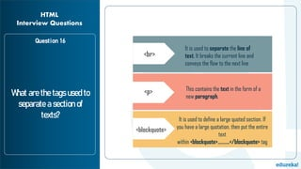

**• What is SVG?**

Svg stands for scalable vector graphics. Svg is used to define vector based graphics for the web.an svg image begins with an <svg> element. The width and height attributes of <svg> element define the width and height of the svg image.

The <circle> element is used to draw a circle. And stroke and fill are attributes of circle tag. The cx and cy coordinates of the centre of the circle. The r attribute defines the radius of the circle.

**Example:-**

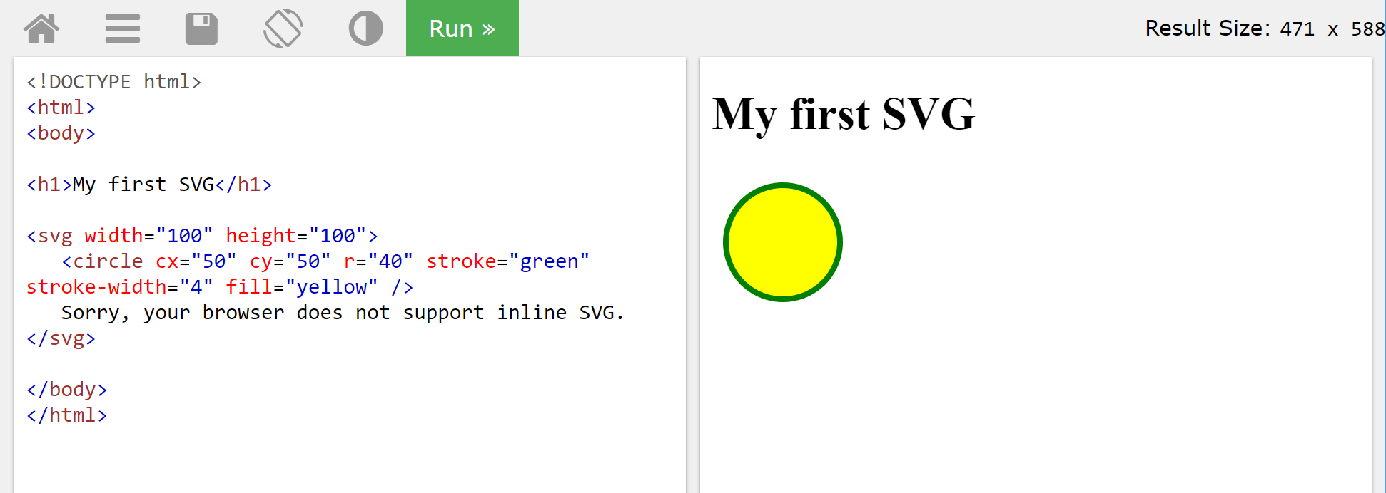

**• What is difference between HTML and XHTML?**

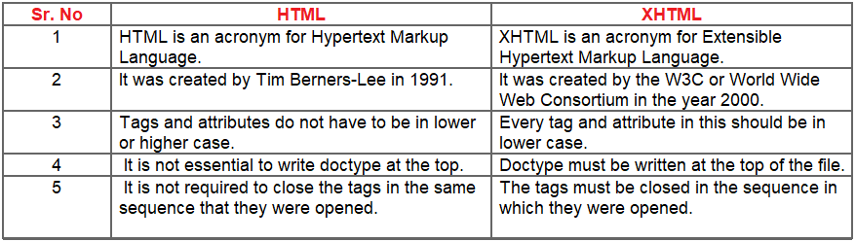

**• What are logical and physical tags in HTML?**

**Physical tags are simple and straightforward tags that decide the appearance of the text.**

**Logical tags are used only to give information about the text, written in the HTML pages**.

